Year 9 – Term 3 – Science Revision

1. **Describe** each of the following in terms of where they are located, their weight and what charge they carry:
2. Proton:

**Positive, one atomic unit, centre**

1. Neutron:

**Neutral, one atomic unit, in the centre**

1. Electron:

Negative, almost nothing, around the centre in shells

1. Using a periodic table, **identify** the number of each type of subatomic particle for the following elements:

|  |  |  |  |
| --- | --- | --- | --- |
| Atom | Protons | Neutrons | Electrons |
| Helium | 2 | 2 | 2 |
| Nitrogen |  |  |  |
| Silicon |  |  |  |
| Chromium |  |  |  |
| Arsenic |  |  |  |
| Thallium |  |  |  |

1. **Explain** how the following are different to an atom.
2. Compound:
3. Ion: (answer should explain cations and anions)
4. Isotope:
5. 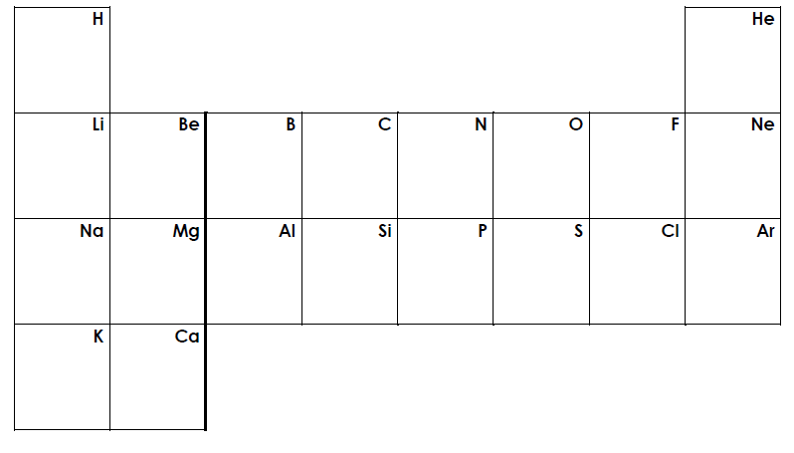**Construct** a diagram showing the electron configuration of the following 20 elements. Your answer should have the electrons in shells.
6. **Identify** the reactants and products in the following chemical reactions. **Construct** a word equation for each reaction.
7. Sulfur burning in oxygen to form sulfur dioxide
8. Magnesium burning in oxygen to form magnesium oxide
9. Sodium fluoride forming when sodium is reacted with fluorine gas
10. Nitrogen reacting with hydrogen to form ammonia (NH3)
11. The formation of phosphorus tribromide by reacting phosphorus and bromine.
12. Hydrochloric acid reacting with sodium hydroxide to form sodium chloride and water.
13. Copper oxide and carbon dioxide forming when copper carbonate is decomposed by heating it strongly.
14. Hydrochloric acid reacting with copper carbonate to form copper chloride, carbon dioxide and water.
15. Aluminium reacting with sulfuric acid to form aluminum sulfate and hydrogen gas.
16. Iron chloride and hydrogen gas being produced when hydrochloric acid reacts with iron.
17. **Identify** the correct second half to complete the following sentences:

|  |  |  |
| --- | --- | --- |
| **First Half of sentence** |  | **Second Half of sentence** |
| 1. Nuclear radioactivity refers to radiation |  | 1. Nuclei in the ground and cosmic rays from space |
| 1. Background radiation is caused by unstable |  | 1. Alpha and beta particles, and gamma rays |
| 1. Most of the radiation we receive comes |  | 1. Are called radioisotopes |
| 1. There are three types of nuclear radioactivity, |  | 1. From background radiation |
| 1. Unstable, radioactive isotopes of elements |  | 1. Made in a nuclear reactor |
| 1. Radioisotopes occur naturally and can also be |  | 1. Given out by unstable atomic nuclei |

1. **Identify** the terms from the pool of terms, which are related to each of the three types of radiation.

Alpha radiation

β

Energy in the form of a wave

Can only be stopped by a thick sheet of lead

Can be stopped by a piece of paper or dead skin

Beta radiation

α

γ

Made of two protons and two neutrons

Made of an electron

Can be stopped by a sheet of aluminium

Gamma radiation

1. Complete the following radioactive decay equations and **identify** the type of decay that occurs.
$${}_{____}^{232}{Th}→ {}_{____}^{____}{Ra}+ {}_{2}^{4}{He}$$

$${}_{29}^{64}{Cu}→ {}_{____}^{____}{Zn}+ {}_{-1}^{0}e$$

$${}_{84}^{216}{Po}→ {}_{____}^{____}{Pb}+ {}_{2}^{4}{He}$$

$${}_{____}^{____}{Be}→ {}_{5}^{10}B+ {}_{-1}^{0}e$$

$${}_{____}^{____}{Ac}→ {}_{87}^{221}{Fr}+ {}_{2}^{4}{He}$$

$${}_{____}^{237}{Np}→ {}_{91}^{____}{Pa}+ {}_{2}^{4}{He}$$

$${}_{87}^{____}{Fr}→ {}_{____}^{222}{Ra}+ {}_{-1}^{_____}e$$

$${}_{_____}^{125}{Sb}→ {}_{52}^{____}{Te}+ {}_{-1}^{0}e$$

2. The half-life of polonium-218 atoms is approximately 3 minutes. What does this mean?
3. **Explain**, in terms of reaction types, what is happening during the following reactions. Classify them as endothermic or exothermic chemical reactions.
4. Cracking a glow stick.
5. Using an instant icepack.

1. Use the table below to **describe** how a Bunsen burner can show both complete and incomplete combustion.

|  |  |  |  |
| --- | --- | --- | --- |
|  | Flame colour | Products | Amount of oxygen |
| Complete combustion |  |  |  |
| Incomplete combustion |  |  |  |

1. Complete the following for the reaction between Propane (C3H8) and oxygen (O2).
2. When propane goes through complete combustion
3. **Identify** the reactants and products.
4. Complete a word equation for the reaction
5. Complete a balanced chemical equation for the reaction
6. When propane goes through incomplete combustion
7. **Identify** the reactants and products.
8. Complete word equations for the reaction
9. Complete balanced chemical equations for the reaction
10. **Identify** the word and balanced chemical equations for:
11. Photosynthesis:
12. Respiration:
13. **Describe** the importance of having chemical equations that are balanced.
14. Using table 1, **predict** the colour each material would give if tested with the indicators shown.

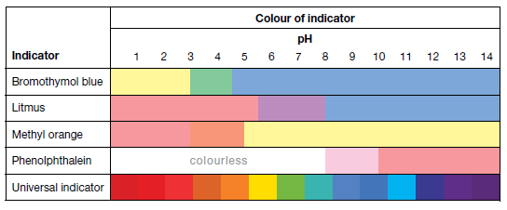

blue

blue

blue

pink

pink

pink

yellow

yellow

green

purple

orange

Light pink

purple

green

red

orange

yellow

|  |  |  |  |  |  |  |
| --- | --- | --- | --- | --- | --- | --- |
|  | pH | Litmus | Bromothymol blue | Methyl orange | Phenol-phthalein | Universal indicator |
| Floor cleaner | 10 |  |  |  |  |  |
| Ammonia solution | 11 |  |  |  |  |  |
| Brass polish | 9.5 |  |  |  |  |  |
| Calcium hydroxide solution | 11.9 |  |  |  |  |  |
| Carpet shampoo | 5.9 |  |  |  |  |  |
| Cream cleanser | 8.8 |  |  |  |  |  |
| Dilute caustic soda | 13 |  |  |  |  |  |
| Dilute nitric acid | 1 |  |  |  |  |  |
| Dishwashing liquid | 5.5 |  |  |  |  |  |
| Kitchen cleaner | 11 |  |  |  |  |  |
| Lemon juice | 2.5 |  |  |  |  |  |
| Milk | 6.8 |  |  |  |  |  |
| Oranges | 3.2 |  |  |  |  |  |
| Oven spray | 12.5 |  |  |  |  |  |
| Tea | 5.2 |  |  |  |  |  |
| Toothpaste | 6.8 |  |  |  |  |  |
| Vinegar | 2.9 |  |  |  |  |  |
| Wine | 3.8 |  |  |  |  |  |

1. Colour in, using 3 different colours, the periodic table below to identify metals, non-metals and the metalloid.

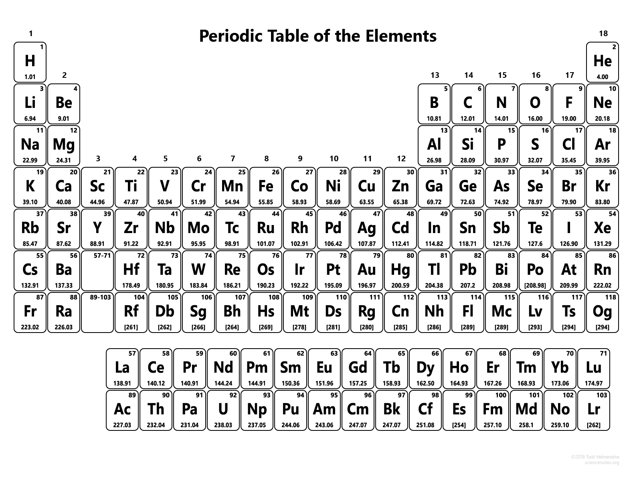

1. List the properties of acids and bases below.

|  |  |
| --- | --- |
| Acids | Bases |
|  |  |

1. On the pH scale below, identify where strong acids, strong bases, weak acids and weak bases approximately sit. Also annotate the scale to show the difference in the concentration of H+ ions.

pH scale

|  |  |  |  |  |  |  |  |  |  |  |  |  |  |
| --- | --- | --- | --- | --- | --- | --- | --- | --- | --- | --- | --- | --- | --- |
| 1 | 2 | 3 | 4 | 5 | 6 | 7 | 8 | 9 | 10 | 11 | 12 | 13 | 14 |

1. When an acid and a base are mixed together:
2. What is the name of the type of reaction?
3. Write a basic word equation for this type of reaction:
4. Explain what is different between a strong acid and a weak.
5. Identify the basic word equation for the reaction of an acid and a metal:

__________________________________________________________________________________

1. Identify the basic word equation for the corrosion of copper:

__________________________________________________________________________________

1. Identify the basic word equation for the reaction of an acid and a carbonate:

__________________________________________________________________________________

1. Using a lit splint, how can you differentiate between the reaction of an acid with a metal, and the reaction of an acid and a carbonate.
2. Compare photosynthesis to respiration in terms of reactants and products, and where these reactions occur. Include as much detail as possible.
3. Explain how gas exchange between living organisms, such animals and plants, exists in a balanced relationship.